Relationship Between Personality of People's Favorite Characters and that of Their Own Personality

Yueqi Li(Cynthia), Tianyu Jiang(Clara), Juyuan Zhao(Jean)

**REPORT**

#### Introduction

Nowadays, watching movies and listening musics are necessary ways for people to relax. People can escape from their busy life and have their private time by doing these things. Some people can also make friends with people whose taste of musics and movies similar to them.

However, there are many disputes about whether there is relationship between the tastes of these things and the characteristics people have. Some people hold the point that people prefer to the things that have semblance features. For example, outgoing person may like to listen to K-POP music and the characters in movies that are brave and positive. On the contrary, other people may think people are more likely to like the things that are complementary with them.

Thus, with this confusion, we are going to study whether there is relationship between the characters students like in the movie Pleasant Goat and Big Big Wolf and students’ Myers-Briggs Type Indicator (MBTI) in grade 11 of Beijing National Day School international department. By conducting careful study in fine conditions, we have eventually constructed a model of Chi-square independence test. The null hypothesis is that there is no association between the preferable characters in Pleasant Goat and Big Big Wolf and their MBTI. And the alternative hypothesis would be there is association between the preferable characters in Pleasant Goat and Big Big Wolf and their MBTI.

#### Background Research

There are not so many papers that focuses on the animation “Pleasant Goat and Big Big Wolf”. We find three resources that discuss the characteristics of roles in this cartoon. The first related research is Associations Between Personality Traits and Music Preference. The researchers gave two tests to 175 participants about their characteristics and types of music they like. Then the researchers found that those scoring low in Neuroticism enjoyed more genres of music. People who scored high and low for Conscientiousness showed no difference in enjoyment. personality traits are associated with an individual’s music preference. Additional factors such as an individual’s age, race, cultural background, or other aspects of personality may also be beneficial to take into account due to the data not supporting all hypotheses. The type of MBTI not only affects the type of music people like, but also movie. In the second related paper, System: A Case Study of Webtoon Contents, found that people with the same MBTI type will select similar emotional words and have similar movie preference. Thirdly, the researchers of the paper Does an Individual’s Myers’s-Briggs Type Indicator Preference Influence Task-Oriented Technology Use found that a person’s MBTI type influences how they organize email and the informational features they rely on when using a decision support system. The definitions of the MBTI dimensions suggest they could be a factor explaining why individuals take different approaches to using software applications. Furthermore, there is a website that analyses the MBTI of all the main characters in Pleasant Goat and Big Big Wolf. We consider it as a related standard to asses the personality of the roles.

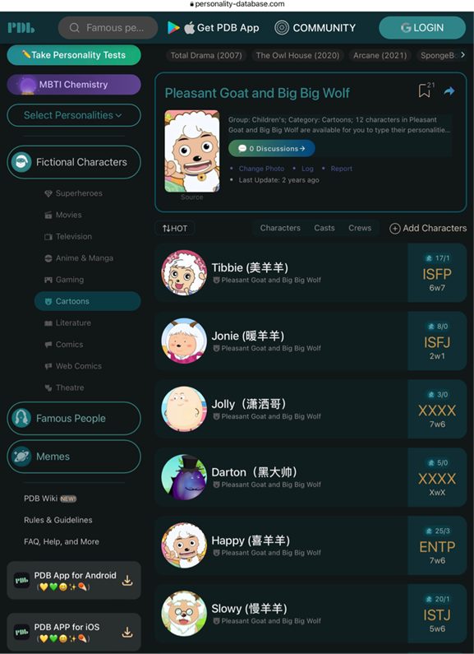

**Figure 1: the website that votes MBTI types of main characters in the anime**

#### Methods and Procedures

Data collection:

We collected our raw data by distributing questionnaires. We randomly selected 45 students at first, however, 5 sets of data we collected can not be used (3 of them have not watched the anime before and 2 of them have not done the MBTI test). To reduce bias, we improve our questionnaire by adding some simple questions to roughly infer the MBTI type of the respondent. We randomly selected 25 students to fill in the new questionnaire. Then we classify data into two categories, the first contains samples with "P" at the fourth place of MBTI, and the second contains samples with "J" at the fourth place of MBTI. The collected data are shown in table 1.

|  |  |  |  |
| --- | --- | --- | --- |
| Judgment/Perception dimension of self | Judgment/Perception dimension of favorite character | | |
|  | Judgment (J) | Perception (P) | total |
| Judgment (J) |  |  |  |
| Perception (P) |  |  |  |
| total |  |  |  |

**Table 1: data collected: J/P Dimension of Favorite Character by J/P Dimension of Self**

Inference: We chose the BNDS G11 students in AP program as our population, so our random sampling among all G11 AP students is representative of the population. We used a random number generator to select 70 numbers with replacement and selected the corresponding students, so each sample is independent of each other. Because the sample size is 70, all expected counts = 70/4 ≥ 5, we can say that the sampling distribution is normal. Thus, all conditions of inference are met.

Hypothesis test: We conducted a Chi-square test for independence with α=0.05 to determine whether there is a relationship between people's own personality and their favorite character's personality.

【process of the hypothesis test】

#### Results

#### Problems in the Project/Suggestions for Future

#### Conclusion